Shabbos Stories for
Parshas behar - bechukosai 5775
Volume 6, Issue 35 27 Iyar 5775/ May 16, 2015
Printed L’illuy nishmas Nechama bas R’ Noach, a”h

For a free subscription, please forward your request to keren18@juno.com

When the Hozeh of Lublin Said Kaddish for His Nursemaid
By Rabbi Reuven Semah

“I shall be sanctified among the children of Israel.” (Vayikra 22:32)

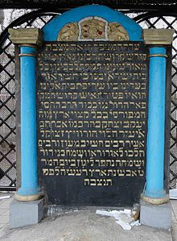
Tombstone of the Chozeh of Lublin

If one would study the meaning of the kaddish that we say when someone passes away, he would discover that the theme is to sanctify the name of Hashem, as the first sentence says –“ May His great name be exalted and sanctified.” As Jewish people, we yearn to praise and make holy His great name.
Rabbi Obadiah Yosef, zt’l, writes in his book Hazon Obadiah about the importance of saying kaddish, especially during the first year of passing, not only in the prayers but also after the study of Torah. The kaddish after Torah study has special power to elevate the soul of the departed. He quotes the Ridbaz and the Arizal that the kaddish after learning has special potency and gives tremendous pleasure to the departed.
Rabbi Yosef tells a story of the Hozeh MiLublin, who had a special time to learn, and he gave instructions to his attendant that he shouldn’t be disturbed. One day the attendant came in and said that there is a woman crying a lot who must see him.
He said to bring her in. As she came in, she asked if he recognized her. He answered that he didn’t, and she told him that she had been his nursemaid. His mother was unable to nurse him, so she was brought as his nursemaid. His father wanted someone who was careful with the berachot on foods, since the foods one eats turns into milk. He wanted everything to be kosher and pure in order that the child should become a great saddik.
All that the father wanted came true. Now the former nursemaid came with a request. All of her children had passed away and she had nobody to say kaddish. Can he [the Hozeh of Lublin] say kaddish for her after she passes away?
The great saddik promised he would do it.
She passed away a few days later, and the Hozeh started saying kaddish for her.
For thirty days the Hozeh did not take his mind off of her. On the thirty-first day, the nursemaid came to him in a dream. Her face was aglow like the sun and her garments shone from one end of the world to the other. She said, “Stop saying kaddish! I don’t want you to say kaddish anymore!”
The Hozeh asked her, “Is my kaddish no good?”
She answered. “On the contrary. It’s too good. Every time you say kaddish, I am raised to another exalted level. Now I sit amongst very righteous women. I don’t understand what they say but it is good for me to be there. If you say kaddish for me tomorrow, they will take me to another place. Thank you very much, but now please stop the kaddish!”

Reprinted from last week’s email of the Jersey Shore Torah Bulletin.

Two Amazing Stories about Rabbi Yehoshua ben Levi
By Rabbi Tuvia Bolton

A great, holy Torah scholar by the name of Rabbi Yehoshua ben (son of) Levi lived in Israel 1600 years ago. Rabbi Yehoshua ben Levi was such an unusually gifted and spiritual person that Elijah the Prophet (Who ascended alive to heaven in a fiery chariot (Kings 2:2:11) some 800 years previously) would regularly appear to him and teach him secrets of Torah.
The Talmud (Sanhedrin 98b) relates that in one of these visits Rabbi Yehoshua ben Levi asked Elijah to arrange a meeting between himself and the Moshiach (a.k.a. Messiah)! He wanted to ask the Messiah a question.
Elijah acquiesced and informed him that the Moshiach could be found sitting at the gates of Rome as a leprous beggar changing his bandages one by one and waiting for G-d’s orders to reveal himself to change the world.
Rabbi Yehoshua followed instructions, located the Moshiach, approached, said 'Shalom Aleichem' and asked his burning question;
“Moshiach, when are you coming?!”
The Moshiach’s answer was, ‘Today' but when, in fact, he did not appear that day Rabbi Yehoshua returned and asked for an explanation. The Moshiach replied, "I meant 'today if you listen to G-d’s voice’".
An even stranger story is found in Talmud Ketuvot (77b).
When Rabbi Yehoshua ben Levi was very old and realized his days were numbered, G-d ordered the angel of death to visit him and give him his last request.
The angel did as told, and when he told Rabbi Yehoshua that he could have whatever he wanted immediately Rabbi Yehoshua responded that he would like to see his place in Heaven before he died.
Now, this is a very strange request seeing that most humans have no way of relating to the spiritual state called ‘heaven’. But Rabbi Yehoshua Ha Levi was totally different. To him heaven was as real, or perhaps more real, than earth.
The Angel agreed, probably figuring that Rabbi Yehoshua wanted to calm his mind in his last moments on earth but before they began the journey, Rabbi Yehoshua asked for a favor; that the angel should temporarily give him his knife (often pictured as a scythe) that he used to end people's lives so he couldn’t frighten him on the way. So the angel, not suspecting what was about to happen, complied, gave him the knife and they set out on their way.
Now the story really gets strange.
The Talmud relates that when the Angel led the Rabbi to the ‘wall’ that surrounds heaven and lifted him up so he could peek over it, suddenly Rabbi Yehoshua grabbed the knife from the Angel and jumped over the wall with it into heaven!
The angel desperately managed to grab a corner of Rabbi Yehoshua’s garment to pull him back but it wasn't enough. The Rabbi had put an end to death!!!
The Angel protested but the Rabbi even took an oath that he would remain in heaven forever. Now nothing could tempt him to return!
The angel was helpless, without that knife Rabbi Yehoshua and everyone else would live forever and he was out of a job!!!
The angel had no alternative but to request Divine intervention. And G-d complied.
G-d decided that the only solution was to annul that vow but that could only be done if the Rabbi had previously in his life made a vow and had it annulled. But if not, nothing could be done …. He would stay in heaven … alive! And the angel of death would be unable to kill him… or anyone else!
And, to the angel's dismay, Rabbi Yehoshua ben Levi won!! Never in his life had he ever annulled a vow and to this day he is listed along with Elijah the Prophet, Moshiach and several others that are alive physically in heaven!
Finally a heavenly voice requested from Rabbi Yehoshua to do a favor, let the world get back to normal and return the knife. Rabbi Yehoshua agreed and that is why people die today!
But the Talmud tells us that there is more to the story.
Because Rabbi Yehoshua, had not allowed the Angel of Death to actually show him his heavenly place he didn't know where to go. So Elijah the Prophet, who was familiar with heaven, jumped in and began announcing “Make place for Ben Levi. Make place for Ben Levi!”
But when they finally located and approached it ‘place’ they found to their dismay that his neighbor was to be none other than the super-holy Rabbi Shimon bar Yochai (who had passed away previously) sitting on 13 golden cushions who refused to let Rabbi Yehoshua sit next to him unless he could answer one-question.
Rabbi Shimon asked, “Was there a rainbow in your days?”
[The meaning of this is as follows. In the days of Noah, because the people were sinners, G-d destroyed them with a flood but put a rainbow in the heavens to remind Him never to do it again (Gen. 9:11-15). But this reminder is only necessary when there are no totally righteous people in the generation. But if there is even one such person, then no matter how evil the people are, his merit will protect them and the rainbow is not necessary.
For instance, in the lifetime of Rabbi Shimon bar Yochai there was never seen a rainbow. Now he was asking Rabbi Yehoshua if he also made the grade.]
Rabbi Yehoshua answered that in fact there was a rainbow. “If so!” declared Rebbe Shimon bar Yochai, “you can’t come here!” And he had to find another 'place' in heaven.
(The Talmud tells us that in fact there was no rainbow in Rabbi Yehoshua’s day but he was so humble he didn’t want to brag and he also felt he didn’t deserve to sit next to Rabbi Shimon.)
From these stories we see the incredible holiness of Rabbi Yehoshua ben Levi; that not only did he speak to Elijah the Prophet and Moshiach, but he even controlled the Angel of Death.
But Rebbi Shimon ben Yochai was totally unimpressed by all this. His only criterion was …. If the rainbow was necessary: namely if Rabbi Yehoshua could protect his generation!
So we see the ultimate measure of man is not his holiness or other accomplishment but rather how many people he truly benefits according to the standards of the Torah.
That is why Rabbi Yehoshua (who, in fact, was as holy as Rebbe Shimon) was only concerned with “When is Moshiach coming?” In other words, his only burning question in life was … when will there be an end to human suffering!

Reprinted from last week’s email from Yeshiva Ohr Tmimim in Kfar Chabad, Israel.
\
A Little Cancer
By Steve Lipman

With her indomitable fighting spirit, Daffy Friedman battled cancer and changed her life.

Dr. Deborah Friedman, a rehabilitation physician in Minneapolis, recently marked a personal anniversary, as she does each year, by taking a moment to thank God, her family, her friends and several organizations that helped her reach a milestone 14 years ago – the remission of her cancer that was diagnosed in 2001. “I think about how wonderful it is to be healthy,” she says, “and I think of all the people suffering with cancer and other illnesses and I pray that they too become survivors.”
Deborah’s continued health, her ability to complete medical school, her opportunity to work in the profession she chose after becoming ill, all confirm how far she has come.
So does her hair, which has grown back in for the fourth time.
A fashion statement for many women, Deborah’s is a statement of survival.
At 18 in early 2001, a sophomore at Baruch College in Manhattan, a poet and artist, the youngest of five daughters in a Modern Orthodox family in Brooklyn’s Borough Park neighborhood, she planned a career in a helping profession – physical therapist, nurse practitioner, or, as a longtime animal lover, a veterinarian.

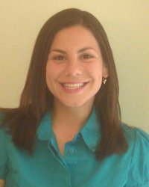

Then she ran a high temperature for a few days. She noticed a rash on her arms and legs. The flu, she thought.
A blood test found that she had an advanced case of acute lymphoblastic leukemia (ALL), a form of the cancer that begins in the bone marrow. Had they discovered the leukemia a week later, doctors told her, she probably would have died.
“I started to cry” – for a minute, Deborah says. “I went through all the stages of grief in a minute or two.”
Then her survival instinct, and her high school and college background as a volunteer at a Brooklyn hospital, kicked in. Deborah – “Daffy” to her friends, an acronym for Deborah Abigail Friedman – and her parents started to coordinate her treatment, which was likely to include a regimen of chemotherapy.
“I thought I was going to die,” Deborah says. Everyone with leukemia whose stories she knew, including an uncle who had died before she was born, had succumbed.
And Deborah had another thought: “I am going to lose my hair.”
Deborah’s physician, Dr. Aaron Rausen of NYU Medical Center, who started treating her a few days after he had undergone s painful back surgery, because “he heard that an 18-year-old Jewish girl was diagnosed with leukemia,” gave her “good news.” He told her that ALL is a “good” type of leukemia, with an 85 percent survival rate for young people.
Chemo began. First, Deborah had her mother shave off most of her hair, to gradually get used to an inevitable bald head.
Deborah spent several weeks in the hospital, helped physically and spiritually by individuals and institutions in the Orthodox community. Her name went on several Tehillim lists of people who recite Psalms for the infirm.
While she was ill, women volunteers from a Satmar chasidic organization brought daily homemade kosher meals that were a godsend to her when she had an appetite and to her visitors when she didn’t, volunteers from the Chai Lifeline organization drove her to medical appointments, and friends of the Friedmans tried to take a load off the family.
If my ancestors survived all that, certainly I can handle a little cancer.
The acts of kindness “brought me closer to my family and my community,” the center of her Jewish identity. Petite, with an ever-present grin, she shows no sign of a bout with a potentially deadly foe.
“Judaism has always been how I find my strength through any hardship, especially cancer,” Deborah says. “I think of our ancestors and everything they endured to protect our people and our faith, and I feel strong. I think of all the times the Jewish people were kicked out of countries, murdered, persecuted, and I feel strong. If my ancestors survived all that, certainly I can handle a little cancer. Tapping into that helped me survive.”
Deborah’s first chemo was a success. She was pronounced in remission within two weeks. But the chemo, which lasted two years, to ensure that it removed any evidence of the disease, was grueling and weakened her. Nevertheless, Deborah remained enrolled in college, taking one course at home during her first semester of illness, returning to school for the rest of her classes. She finished in 3 years, with a near-A average.
Cancer changed Deborah’s career trajectory – to medicine, either a Ph.D. in medical research or a medical degree. “I wanted to cure cancer, or treat people who have cancer. I wanted to give back.” On Dr. Rausen’s urging, she decided to become a physician.
Surviving cancer, completing college despite chemo, turned out to be a hidden blessing. “It motivated me to work harder,” Deborah says. “In a weird way, cancer gave me a lot of confidence.” Confidence that she could handle a medical curriculum. “Before that, I didn’t think I was smart enough.”
She studied at Tel Aviv University’s Sackler Medical School.
“Israel, surrounded by so much hate, winning every war, enduring as a haven for Jews everywhere, has always been an inspiration to me,” she says. “That was partly why I decided to run off to med school there just four months after finishing chemo. Somehow I thought it would protect me from the cancer returning. Not very scientific, but it worked!”
At Sackler Deborah met her husband, Ryan Shapin, a fellow medical student. Now they’re working in Minneapolis, where Deborah is a rehabilitation physician, a specialty she loves. Sometimes she treats patients with cancer. Away from the job, she’s a board member of the Darchei Noam synagogue.
Deborah’s hair has grown back. Several times. Now she donates it, instead of blood (a leukemia history rules that out).
When chemo claimed her hair, she got a pair of wigs – one at a shaitelmacher(wig maker) in Brooklyn’s Flatbush neighborhood, most of whose clients included young women like her day school classmates who had already gotten married.
Deborah’s hair first reached shoulder length again while she was in medical school, in 2005. She had it cut, near the 2-year anniversary of the end of her chemo, donating her locks – and both wigs – to Zichron Menachem, an Israeli organization in that helps children with cancer.
Two years later, and two years after that, in her medical residency in Buffalo, she had her re-grown hair cut again, donating it to the Locks of Love Organization.
A few years later, in Minneapolis, she had her hair cut again, giving it that time to the Beautiful Lengths program of the Pantene shampoo manufacturer.
Now her hair is getting longer again. Donations need to be at least ten inches. “It’s not long enough yet – it may take another year – but I’m looking forward to donating it again.”

Reprinted from the April 27, 2015 website of Aish.com

Short Story of the Week

The Danger of Outside Influences Corrupting One’s Mind

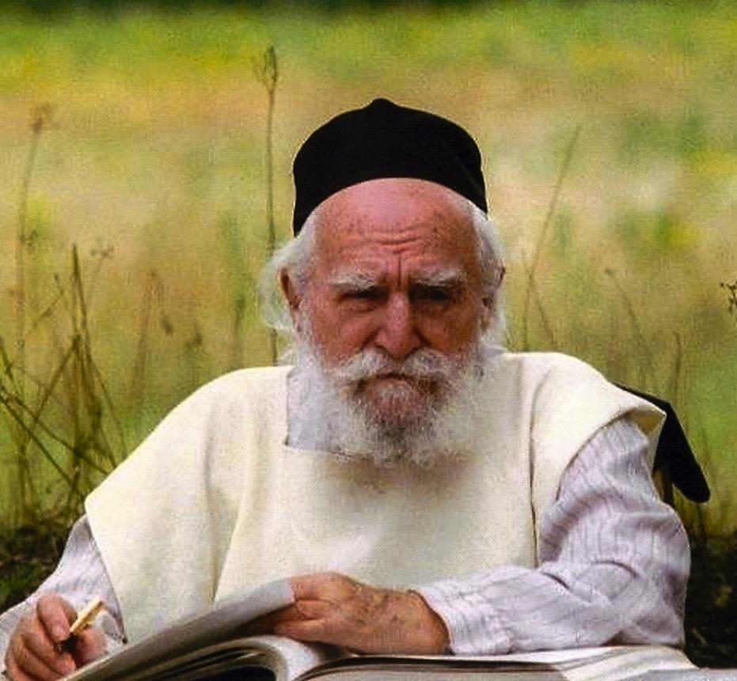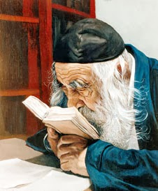
Rav Moshe Feinstein, zt”l The Steipler Gaon, zt”l
The Steipler, of blessed memory, once sent a messenger toRav Moshe Feinstein, of blessed memory, regarding an important issue which the Steipler wanted Rav Moshe to become involved in. The messenger discussed the issue with R' Moshe and told him all the details.
When he was finished, he pulled out a Jewish newspaper, explaining that this newspaper happens to have an article about the matter. Rav Moshe declined to take the newspaper, saying that he had already heard the details so there was no need for him to see the article. The messenger persisted, explaining that it was possible that he missed one or two important details.
Rav Moshe responded, "I have not held a newspaper in my hands for seventy years. As soon as I read a newspaper, I will no longer be qualified to pasken because my mind will not be one hundred percent Da'as Torah (Torah understanding)."
Comment: This is not a rant against newspaper reading. This is an appeal for maintaining a Daas Torah-mindset. The more outside influence we allow into our minds, the more diluted our understanding is of Hashem’s Torah and the realities of the world.

Quote of the Week
“Don’t pray for the death of sinners; pray for the end of their sins.”
Talmud (Berachos 10a), quoting Bruriah, Rabbi Meir’s saintly wife. Bruriah suggested this approach to R’ Meir when hooligans were bothering him. Instead of labeling others and lumping a person with the action, we would be better of condemning bad actions and building people.

Reprinted from last week’s Parsha email from Mendel Berlin.

Shabbos Treasures
The Nazi and the
Kabbalas Shabbos Surprise

In all matters of life we have to sense Hashgacha Pratis, Divine Providence from Above, at all times. Even in the most dire of times and circumstances we must sense the guidance of Hashem. In 1943 during the Holocaust of European Jewry, when the Children Israel were being murdered and slaughtered through Kiddush Hashem, there were still times that it was quite clear that Hashem was watching over His Nation of Israel.
It had already been more than three years since the Nazis invaded France, yet, the main shul in Lyon continued to operate and function, and conducted regular minyanim. One Erev Shabbos, the militia of the city of Lyon known as ‘The great shock of the Vichy government’, decided that it was time to disrupt the
prayers of the Jews and to destroy the synagogue.
The Rav of the shul, who survived the war with amazing Hashgacha, relates that on that particular Friday evening during Kabalas Shabbos, a Nazi furtively came into the shul and stood in the back. He was holding three hand grenades. His intent was to throw them at the congregation and then immediately run outside.
The Nazi opened the door of the shul and entered without being detected. A few moments after entering the shul, he armed the grenades and wanted to throw them. However, what happened at the very next moment shocked him and he stood wide-eyed as the grenades fell from his hand where he stood and he ran for his life. Indeed, the explosion injured some of the mispalelim, but Baruch Hashem there was no loss of life.
What made the Nazi run? At the exact moment that he wanted to throw the grenades at the congregants, the entire congregation – as one – turned towards the back of the shul where he was hiding. He thought that they had received some kind of sign or symbol that someone wanted to harm them, and they were turning on him to get him. He did not understand what happened and who informed on him. He did not understand how he could enter the shul without being detected, and how it was that every person without exception turned around towards him??!
What really happened was that at that exact moment, the congregation reached the last stanza of ‘Lecha Dodi’ – ‘Bo’ei b’shalom ateres ba’alah’, ‘Enter in peace, O crown of her husband’, when every congregation in all of Israel turns towards the back, towards the entrance to greet the Shabbos with joy and delight.
The lesson from this is that although we might find ourselves in the worst possible situation and it seems that there is no hope at all, we still must believe in our hearts that HaKadosh Boruch Hu is able to rescue us from any distress, and from any tragedy and illness, and if we continue to have faith and to totally rely on Him, then we will merit salvations and consolations. Only He knows all the times and only He arranges all that is happening in the world, and only Hashem could prevent the curse from entering the shul at the exact moment that the congregation was greeting the Shabbos.
Just as Hashem brought salvation to that shul, may we continue to have faith in Him and may He bring an immediate end to our exile! (Borchi Nafshi as quoted in the sefer He’emanti Va’adabeirah)

Reprinted from last week’s email of “Torah U’Tefilah: A Collection of Inspiring Insights” compiled by Rabbi Yehuda Winzelberg.

Orthodox Jewish Army Chaplain Colonel Jacob Goldstein Retires

Colonel Jacob Goldstein, a United States Army Reserve chaplain, was given a ceremonious military sendoff as he retired from a long, celebrated and unparalleled career on Wednesday.
Goldstein was joined by family members, military personnel and fellow Chabad rabbis at his retirement of 38 years of service at the Joint Base Myer-Henderson Hall located around Arlington, Virginia.
“I don’t know,” the 68-year-old replied when asked by COLlive.com how he feels following the ceremony. “A good part of my life was guided by the military and now I am not going to get urgent calls and taking unexpected trips.”
Serving since 1977, his international combat missions include Bosnia, South Korea, Afghanistan and Guantanamo Bay, Cuba. On each of these trips he would service the spiritual and morale needs of Jewish men and women in uniform. That included leading High Holiday services on bases and providing kosher meals.
“It was a great honor to be a Jew in the military and for me to wear the uniform of our country,” he added. “I hope that in the coming years, especially with Chabad people trying to join the military as well, there will be an opportunity to make a similar Kiddush Hashem.”
Rightfully seen as a trailblazer, Goldstein was one of only 7 Orthodox Jewish chaplains serving in the Army and, until recently, was the only member of the armed forces with a full-length Chassidic beard.

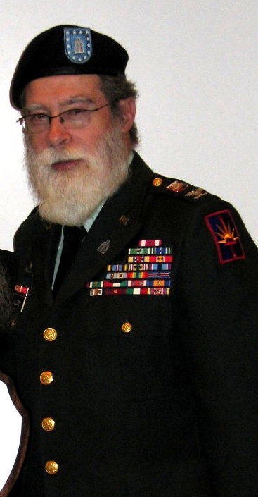
Colonel Jacob Goldstein

His facial hair caused quite a stir in an environment where clean-shaven faces and finely trimmed haircuts are standing orders, an army specialist once observed. “I’ve never seen a person in the military with a beard before,” a Private remarked upon meeting Goldstein.
Goldstein’s years of service and dedication have become a legend in Jewish circles and inspired Chabad rabbis to follow suit. In 2011, Rabbi Menachem Stern won a legal battle to keep his beard as an Army chaplain. In 2014, Rabbi Elie Estrin became the first bearded chaplain in the U.S. Air Force.
The idea to serve came while Goldstein was a student at the Central Lubavitch Yeshiva at Lubavitch World Headquarters in Brooklyn, NY. As part of the Lubavitcher Rebbe’s campaign to encourage Jewish observance, Goldstein visited army bases and “began to build a rapport with the Jewish soldiers.”
After some time, a senior Christian army chaplain approached him. “You are doing such good work with the soldiers-we need you in the army. Who is your chief bishop? I would like to write him to ask him to send you to us,” the man said.
Goldstein said he would write in to the Rebbe. “The Rebbe agreed that it was a good idea, and I enrolled, beginning the first of many eventful years as an army chaplain,” he recalled in an article.
The U.S. Army website notes that Goldstein was also instrumental in stateside affairs. As chief chaplain of the New York Army National Guard, his was one of the first military units to response to the terror attack of September 11, 2001 on the World Trade Center.
He and his team were eyewitnesses to the tragic events at Ground Zero. He tended to the spiritual needs at the site of the fallen towers and shared his experiences during the four and a half months he spent at Ground Zero in a series of videos titled “The Rabbi of Ground Zero” on Chabad.org.
Speaking to COLlive.com, Goldstein described the hardships he endured. “Burying a soldier is difficult, but what was even more difficult was notifying the families about the death. You are going to someone who sent a perfectly healthy son or daughter to the army and telling them what happened. It is a tremendously difficult and emotional time.”
Goldstein said he got through those tough times by focusing on the mission. “I was focused on my mission as a chaplain. Our country has been at war for the last 14 years and it’s not over… I hope to continue my role as a mentor.”
COLLIVE.COM

Reprinted from the website of Matzav.com
Story #910

After Nine Miscarriages
From the desk of Yerachmiel Tilles
editor@ascentofsafed.com/

I [Esther Ben-Yosef] want to tell you about the miracle that happened to me. I'm originally from Holland, so my native language is Dutch. I also speak German and French. My English is not so great but I will try.
After my first-born son I suffered severe problems with pregnancies. I had 9 miscarriages and the many doctors I'd been to all gave up on me being able to give birth again. The final thing they were willing to try was an IVF treatment. I already had an appointment for it and been through the required injections that I needed for the treatment.
On Lag B'Omer 5764 (2004) we went for the first time to Meron, after a religious woman advised me to go. I prayed there with all my heart for a baby and a brother/sister for my son who was 9 years old at that time. One week after Lag B'Omer I dreamt that I give birth--the dream was so real that I felt contractions!
Three weeks after that Lag B'Omer I cancelled the treatment because I was pregnant, and nine months later Jonathan-Shimon was born. It took ten years but he was worth it!
After Jonathan Shimon was born I went to Meron again on Lag B'Omer the following year to say "Thank you," and within a month I was again pregnant. Daniel-Yisrael was born nine months later.
The pregnancies also involved miracles, specially the second one. With Jonathan Shimon there were many difficulties. In the end he was born very small, but today (5770/2010) he is a very healthy 5 year old boy, thank G-d.
When I was 8 weeks pregnant with Daniel I went for an ultrasound. The doctor told me that he had bad news: there was no heartbeat. He also showed me the bloodstains in the uterus on the screen. He said that if I will not discharge the fetus naturally within a week I should go to the Hadassah-Hospital for curettage.
Upon stepping outside I started to cry. My 12 year old son said to me, "Ima ('Mom'), don't worry, I promise you that everything will be alright. The doctor was wrong." I told him, "Honey, I know you want another brother or sister, but the doctor told me that it is really not okay." I was surprised when he replied to me firmly, "No. I feel that this time you don't need to worry."
I went a week later I followed the doctor's instructions and went to the hospital. Before the curettage they made another ultrasound. The woman technician was excited by the results. "Mazaltov!" she exclaimed. "You can go back home...I see a heartbeat!" I was amazed and very very happy.
Then, when I was five months pregnant, I had to go for another ultrasound examination. Again I was given very bad news. This time I was told that I had almost no amniotic fluid in the uterus anymore. The doctor said that there is practically no chance that the baby will survive. He advised me to abort. I went to three other doctors for advice and they all agreed with the first one's prognosis. One of them (an orthodox Jew) allowed that I could try, but he didn't think there was much hope.
I stayed in bed a lot and prayed constantly for this baby. Every week I went for an ultrasound and every week I had a bit more fluid. At the end of the pregnancy everything was back to normal and I gave birth to a beautiful healthy boy.
I learned from my experiences that you cannot trust anybody in this world, only G-d the Creator. I am very thankful for the wonderful gifts that He gave me.
P.S. I told my story to two women who wanted to get pregnant for a long time. One was trying already for two years and another one for ten years. They also became pregnant the same month after they went to Meron to pray, and they both had healthy children.
~~~~~~~~~~~~~~~~~~~
Adapted by Yerachmiel Tilles from two letters of Esther Ben-Yosef posted on //rashbi.org, a dedicated website for Lag b'Omer at Meron.
Reprinted from last week’s email of KabbalaOnline, org, a project of Ascent of Safed.
www.ascentofsafed.com ascent@ascentofsafed.com

Chani and Chezki Lifshitz Doing “Extraordinary” Work In Nepal Rescue Efforts
By Anav Silverman

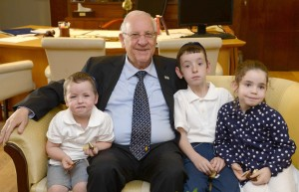
Israeli President Reuven Rivlin hosting the Lifshitz children

Having sent their children to the safety of Israel, Chani and Chezki Lifshitz, the Chabad emissaries based in Kathmandu have stayed behind to continue spearheading recovery efforts in light of the massive earthquake to hit the Nepal on April 25.
Rabbi Chezki Lifshitz travelled by helicopter on Wednesday, helping to rescue 25 stranded Israelis, who were stuck without food, water, or electricity in remote villages of Nepal. The Chabad House of Thamel Kathmandu is also bringing food to Nepalese refugee camps.
The Chabad House has also been working to track down stranded Israelis and keeping the Chabad House Thamel Kathmandu Facebook page updated with reports for worried families, while making sure hot meals are available for those Israeli trekkers returning.
Meanwhile, the Lifshitz couple’s three children were sent to Israel on a special flight with rescued Israelis on Tuesday, along with their Nepalese carer Lolita, who lives with the family at the Chabad house in Katmandu. The children, Shmuel, Rivki, and Yitzchak, aged four to six, were hosted by Israeli President Reuven Rivlin at the President’s Residence together with their grandmother Yehudit Fleischman and Lolita.
During their visit, the President gave them chocolate and heard their experiences over the recent days. Rivlin also telephoned Rabbi Chezki and his wife in Nepal and had their children speak with them.
The Lifshitzs were very moved by the phone call, and thanked the President for the warm welcome he gave their three small children. “We are all one nation! Although dad and mom stayed behind in Nepal to help, the President of the State of Israel took care of our children personally,” wrote the Lifshitzs in a Facebook post following the conversation.
“The work you are doing for the whole world, and of course for the Israelis in Nepal, is extraordinary, from a Jewish, Israeli, and universal perspective,” President Rivlin told the Chabad couple during the phone call.
“Just as you open your home to the whole world, we are delighted to open our home to your children. We will look after them, and through them extend to you our thanks,” he said.

Reprinted from the April 29, 2015 website of Matzav.com (Tazpit News Agency)

Pearls of Wisdom…A Word for the Ages

Rav Yaakov and
The Alarm Clock
Once, Rav Yaakov Kamenetsky, zt”l, was supposed to meet someone at Penn Station in Manhattan at 7:00 AM, to go on a trip together out of town. Rav Yaakov arrived at the station looking exhausted, having been up for the entire night.

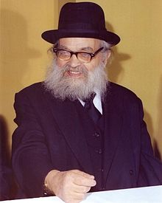
Rav Yaakov Kamenetsky
He explained to his friend that when he had gone to set his alarm clock before going to sleep the night before, he remembered that his gentile neighbor worked the night shift and would have just gone to sleep at the time that the alarm clock was set to go off.
It was a hot summer night when everyone slept with their windows open, and the neighbor would quite possibly be awakened by the alarm. Therefore, in his sensitivity, Rav Yaakov did not set his alarm clock. Instead, he stayed up all night and learned to make sure that he would be on time for his early departure! (adapted from “Five Great Lives.)

Reprinted from last week’s email of “Torah U’Tefilah: A Collection of Inspiring Insights” compiled by Rabbi Yehuda Winzelberg.

